**

Mohammad Ali Jinnah University

Chartered by Government of Sindh - Recognized by HEC

Assignment 3

**Subject**: DBMS

**Section**: BM

**Teacher**: Saif Islam

**Muhamad Fahad** (FA19-BSSE-0014)

(FA19BSSE0014@maju.edu.pk)

Assignment 3

Question # 1

1. **Implement the above ERD as-it-is in SQL server. Name of the entities, attributes and all constrains must be the same. (2 Points):**

CREATE DATABASE Assignment3

USE Assignment3

CREATE TABLE CUSTOMER(

customer_id int not null PRIMARY KEY,

customer_name varchar(50) not null,

customer_email varchar(50),

customer_no int unique not null,

customer_address varchar(150),

customer_postcode int,

)

CREATE TABLE PRODUCT(

product_id int not null PRIMARY KEY,

product_name char(50) not null,

manufacturer char(50),

price int not null,

in_hand int,

)

CREATE TABLE SALES(

customer_id int not null FOREIGN KEY (customer_id) REFERENCES CUSTOMER(customer_id),

product_id int not null FOREIGN KEY (product_id) REFERENCES PRODUCT(product_id),

unit_price int not null,

quantity int not null,

date_purchased date not null,

)

1. **Insert at least FIVE records in customer and product table and TEN records in Sales. (2 Points)**

-- 2

INSERT INTO CUSTOMER VALUES(001,'John','John@company.com',1,'39 stress ABC road',123)

INSERT INTO CUSTOMER VALUES(002,'Turnquist','Turnquist@company.com',2,'39 stress ABC road',132)

INSERT INTO CUSTOMER VALUES(003,'Norberto Bellini','Bellini@company.com',3,'39 stress ABC road',145)

INSERT INTO CUSTOMER VALUES(004,'Lucio Fenske','Lucio.Fenske@company.com',4,'39 stress ABC road',178)

INSERT INTO CUSTOMER VALUES(005,'Kristel Shehan','Shehan@company.com',5,'39 stress ABC road',159)

INSERT INTO PRODUCT VALUES(85,'oil','2021-5-12',39,159)

INSERT INTO PRODUCT VALUES(88,'water','2021-5-12',55,32)

INSERT INTO PRODUCT VALUES(02,'fish','2020-8-5',45,75)

INSERT INTO PRODUCT VALUES(58,'fruit','2015-6-20',11,45)

INSERT INTO PRODUCT VALUES(75,'crops','2018-4-22',05,88)

INSERT INTO SALES VALUES(001,75,05,1,'8/2/2021')

INSERT INTO SALES VALUES(005,75,05,4,'4-12-2019')

INSERT INTO SALES VALUES(003,58,11,2,'7-5-2016')

INSERT INTO SALES VALUES(005,58,11,2,'1-4-2020')

INSERT INTO SALES VALUES(002,02,45,5,'1/12/2019')

INSERT INTO SALES VALUES(005,58,05,4,'11-12-2021')

INSERT INTO SALES VALUES(003,88,55,1,'7-22-2020')

INSERT INTO SALES VALUES(004,02,45,1,'8-05-2018')

INSERT INTO SALES VALUES(004,58,05,4,'4-12-2019')

INSERT INTO SALES VALUES(002,85,39,8,'8-28-2021')

INSERT INTO SALES VALUES(001,88,55,4,'5-12-2019')

INSERT INTO SALES VALUES(003,02,45,4,'8-1-2019')

INSERT INTO SALES VALUES(005,85,39,10,'8-6-2019')

INSERT INTO SALES VALUES(004,58,05,8,'8-6-2019')

1. **Display the structure of each table using sp_columns and attach the screenshots.**

sp_columns CUSTOMER

sp_columns PRODUCT

sp_columns SALES

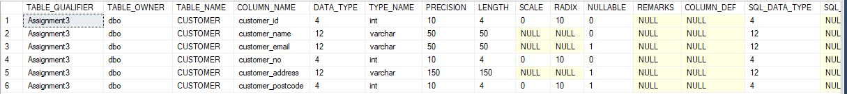

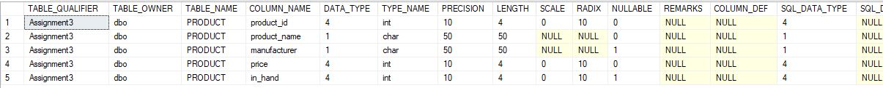



1. **Display all the records from each table using select and attach the screenshots.**

-- 4

select * from CUSTOMER;

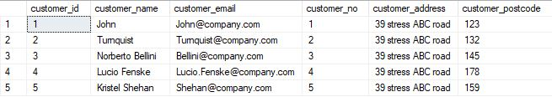

select * from PRODUCT;

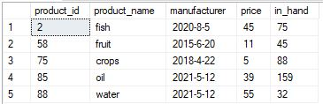

select * from SALES;

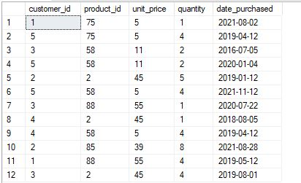

Question # 2

1. **Write a query to show that how many items of EACH product are sold in the month of January. Sort the records in decreasing order of product quantity. (1 Point)**

select product_id, sum(quantity) as 'Product Sold' from SALES

where MONTH(date_purchased) = 1

group by product_id

order by product_id desc



1. **Select Name, contact and postal code of the customer who has done MAXIMUM transactions in the month of June. (1 Point)**

select c.customer_name,c.customer_no,c.customer_postcode,(quantity) AS 'MAXIMUM transactions' from CUSTOMER c,

SALES s

where c.customer_id = s.customer_id

and (quantity) =

(select max(quantity) from SALES

where MONTH(date_purchased) = 6)



**A change in question is that the month is 8 not 6**

select c.customer_name,c.customer_no,c.customer_postcode,(quantity) AS 'MAXIMUM transactions' from CUSTOMER c,

SALES s

where c.customer_id = s.customer_id

and (quantity) =

(select max(quantity) from SALES

where MONTH(date_purchased) = 8)

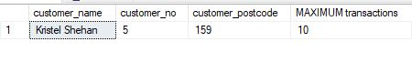

1. **Select Name, contact and postal code of the customer who has spent MAXIMUM amount on sale till date. (1 Point)**

select c.customer_name,c.customer_no,c.customer_postcode,(quantity*unit_price) AS 'MAXIMUM amount' from CUSTOMER c,

SALES S

where c.customer_id = S.customer_id

and (S.quantity*S.unit_price) =

(select max(quantity*unit_price) from SALES)



1. **Display the name, price and manufacturer of the product with second highest price. (1 Point)**

select product_name,price,manufacturer from PRODUCT

where price =

(select max(price) from PRODUCT

where price <

(select max(price) from PRODUCT))



1. **Display all product from product table with inventory status. (If product_in_hand &lt; 10, status is low. If product_in_hand &gt;=10 &amp; &lt;=50, status is satisfactory. If product_in_hand 50, status is surplus). (2 Points)**

-- 5

select *,

CASE

WHEN in_hand < 10 THEN 'status is low.'

WHEN in_hand BETWEEN 10 AND 50 THEN 'status is satisfactory.'

WHEN in_hand > 50 THEN 'status is surplus'

END As inventory_Status

from PRODUCT;

